White box documentation

Objective:
The purpose of white-box testing is to verify the internal logic of the Account class, including all branches, conditions, and loops. The goal is to ensure that deposits, withdrawals, and transfers behave correctly under all possible conditions (e.g., invalid amounts, overdrafts, non-verified accounts, and valid transactions).

Modules/Methods Tested:
- Account.java
- deposit(double amount)
- withdraw(double amount)
- transfer(double amount)

Lessons Learned:
- White-box testing provides confidence in internal logic correctness.
- Creating Control Flow Graphs helps in identifying untested branches.
- Combining white-box testing with black-box testing ensures comprehensive testing coverage for both expected and unexpected inputs.

Control Flow Analysis:
Deposit:
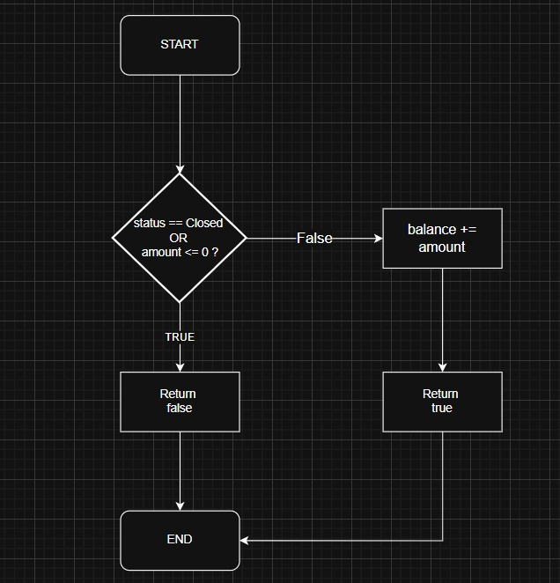

Withdraw:
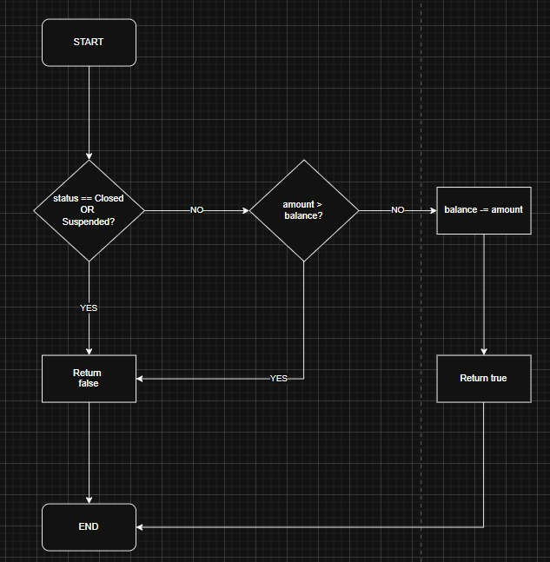

Process Transaction:
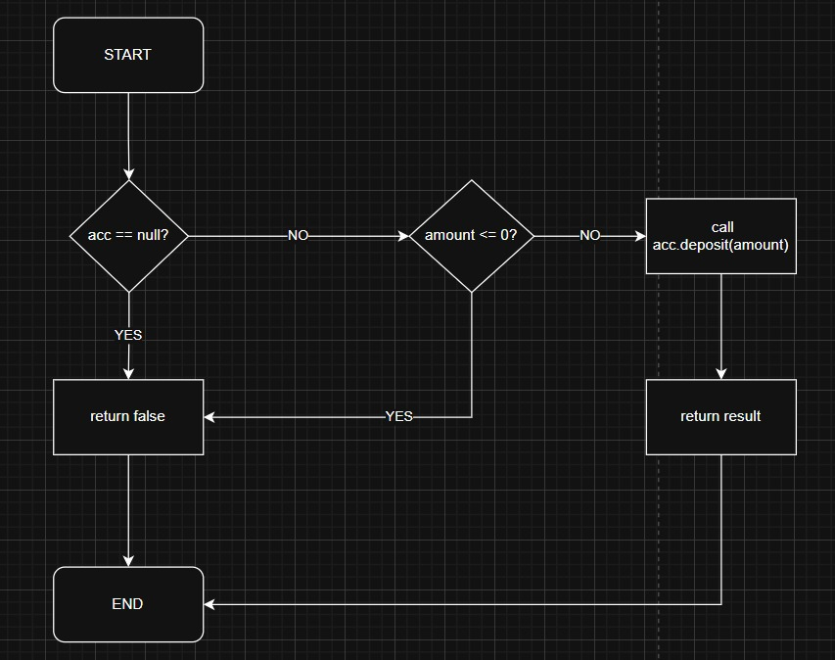

Test Cases and Coverage:
Method | Test Case Description | Expected Result | Branch Covered
deposit | Deposit negative amount | false | amount <= 0 branch
deposit | Deposit on closed account | false | status == CLOSED branch
deposit | Deposit valid amount | true | success path
withdraw | Withdraw from suspended account | false | status != VERIFIED branch
withdraw | Withdraw exceeding balance | false | amount > balance branch
withdraw | Withdraw valid amount | true | success path
transfer | Transfer from closed account | false | status != VERIFIED branch
transfer | Transfer exceeding balance | false | amount > balance branch
transfer | Transfer valid amount | true | success path

- All decision points (if statements) in deposit, withdraw, and transfer are tested.
- Loops: None exist in these methods.
- Exceptions / Edge Cases: Negative amounts, overdrafts, and invalid account statuses are handled.

Results / Observations
- All tests passed successfully.
- Branch coverage for Account.java is 93–100%, indicating that almost all logical paths were exercised.
- This white-box testing ensures:
- Invalid deposits, withdrawals, and transfers are blocked
- Correct updates for valid operations
- Edge cases like overdrafts and non-verified accounts are handled

